This lab requires you to:
- Use the Law of Sines to solve oblique triangles.
- Use the Law of Cosines to solve oblique triangles.
- Use Heron’s formula to find the area of a triangle.
- Solve applied problems.
Answer the following questions to complete this lab:
- Define the Law of Sines.
- Define the Law of Cosines.
- Describe in two or three sentences the Ambiguous Case.
- Solve the triangle. Round lengths to the nearest tenth and angle measure to the nearest degree.
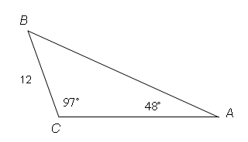
Find the value of B, b, and c.
- Two sides and an angle (SSA) of a triangle are given. Determine whether the given measurements produce one triangle, two triangles, or no triangle at all.
a = 7, b = 5, A = 70°
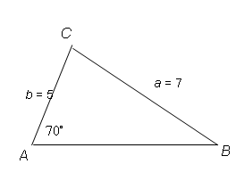
- A surveyor needs to determine the distance between two points that lie on opposite banks of a river. The figure shows that 300 yards are measured along one bank. The angles from each end of this line segment to a point on the opposite bank are 620 and 530. Find the distance between A and B to the nearest tenth of a yard.
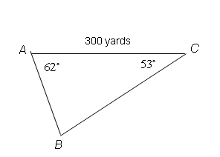
- The diagram below shows three islands in Florida Bay. You rent a boat and plan to visit each of these remote islands. If you are on island B, on what bearing should you navigate to go to island C?
Island A
Island C
Island B
6 miles
5 miles
7 miles
NW
N

- Use Heron's formula to find the area of the triangle. Round to the nearest square feet.
a = 5 feet, b = 5 feet, c = 4 feet.

Submission Requirements: Answer all the questions included in the lab. You can submit your answers in a Microsoft Word document, or write your answers on paper and then scan and submit the paper. Name the file as InitialName_LastName_Lab5.1_Date.

Evaluation Criteria:
- Did you show the appropriate steps to solve the given problems?
- Did you support your answers with appropriate rationale wherever applicable?
- Were the answers submitted in an organized fashion that was legible and easy to follow?
- Were the answers correct?

