**1.** Find the domain of the function f(x) = .

1) ______

(A) D = (-, 2) (2, )

(B) D = (-, -2) (-2, )

(C) D = (2, )

(D) D = (-2, )

(E) none of the above

**2.** A cell phone company offers a plan of $39 per month for 400 minutes. Each additional minute will cost $0.25. Find a piecewise function to represent the monthly cost C of this plan as a function of the total monthly calling minutes x.

2) ______

(A) C(x) = 

(B) C(x) = 

(C) C(x) = 

(D) C(x) = 

(E) none of the above

**3.** According to the Center for Disease Control and Prevention, Table 1 shows the growth rate of the deadly Ebola Virus and the number of deaths in a small city whose initial population was 120,000 would result from the Ebola virus if left untreated after x weeks.

TABLE 1

|  |  |
| --- | --- |
| x (weeks) | P (infected) |
| 0 | 5714 |
| 0.5 | 11486 |
| 1 | 21968 |
| 1.5 | 38610 |
| 2 | 60128 |
| 2.5 | 81613 |
| 3 | 98185 |
| 3.5 | 108602 |
| 4 | 114332 |
| 4.5 | 117254 |
| 5 | 118687 |
| 5.5 | 119376 |
| 6 | 119705 |

1. Use the data to estimate the average growth rate of the disease from week 2 to week 4.
2. Use the data to estimate the growth rate of the disease on week 4.

3) ______

(A) (i) 8,652 people/week; (ii) 27,102 people/week

(B) (i) 54,204 people/week; (ii) 8,652 people/week

(C) (i) 27,102 people/week; (ii) 8,652 people/week

(D) (i) 27,102; (ii) 11,460 people/week

(E) none of the above

**4.** The graph in Figure 1 shows the pH level P in a human mouth as a function of the time t (in minutes) after sugar is consumed. Use the tangent lines to estimate rate of change of pH level in the mouth with respect to time at t = 4 minutes and t = 13 minutes.

Figure 1



●

●

Time (minutes)

pH Level

0

1

2

3

4

5

6

7

10

20

30

40

50

60

70

4) ______

(A) Approximately 4.1 at t = 4 minutes; approximately 5.5 at t = 13 minutes.

(B) Approximately -2 at t = 4 minutes; approximately 1 at t = 13 minutes.

(C) Approximately -1/2 at t = 4 minutes; approximately 1 at t = 13 minutes.

(D) Approximately 1/2 at t = 4 minutes; approximately 1 at t = 13 minutes.

(E) none of the above

**5.** Use the graph in Figure 2 to find each of the following, provided it exists. If it does not exist, explain why.

Figure 2

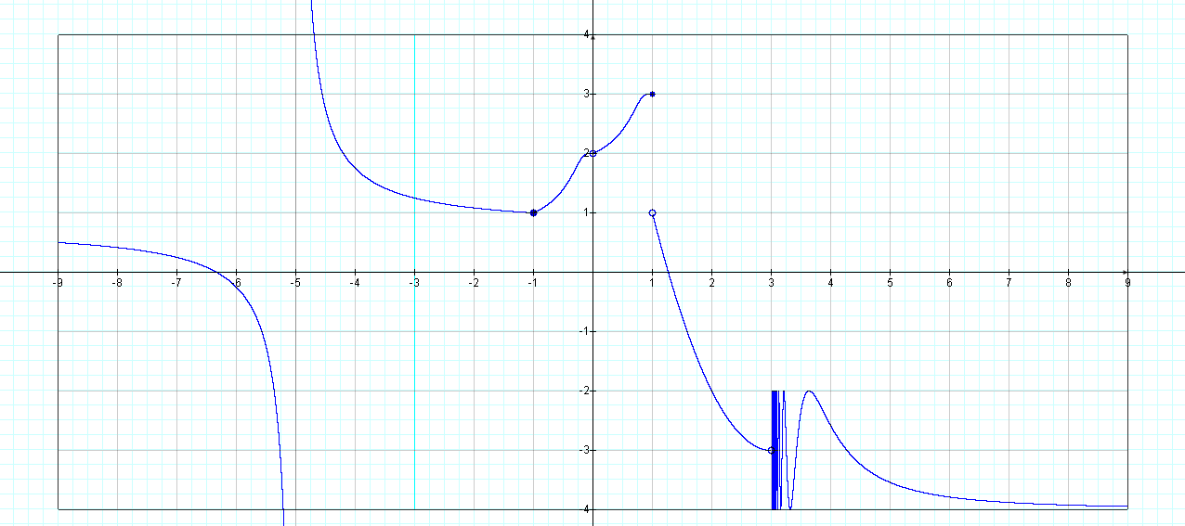

(a) V(s) (b) V(s) (c) V(s)

5a) ______

5b) ______

5c) _____

**6.** Use the graphs of F and G in Figure 3 and the Limit Principles to find the following limit if it exists.

[2F(x) – 3G(x)]

Figure 3

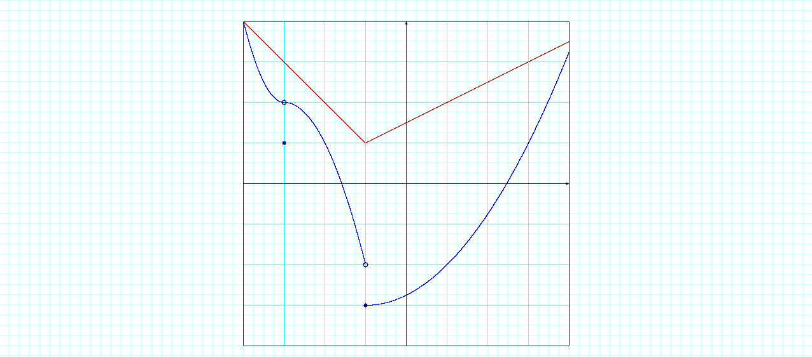

-3

-2

G(x)

F(x)

-1

-3

1

2

-2

3

2

-1

0

1

6) ______

(A) -3 (B) 0 (C) 1 (D) 2 (E) none of the above

**7.** Suppose L represents the limiting value of the following limit expression.Find L using the limit principles for infinite limits (You must show all your work to receive full credit; no short cuts ☺):

L = 

(A) L 🡪 

(B) L = 2/9

(C) L = 0

(D) L = 2/3

(E) none of the above

7) ______

**8.** According to data collected by the World Health Organization and the World Bank, mean life expectancy can be modeled as a function of Gross National Product per capita. Let g represent the GNP per capita of a particular country and E represent the life expectancy. Use the model in Figure 4 to estimate and interpret E(g).

8) ______

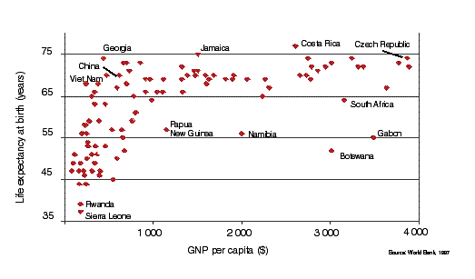

**9.** Let p(x) = x5 – 3x4 + 2x – 1. Use the Intermediate Value Theorem to show there is a zero of the polynomial p(x) in the interval (2, 3).

9) ______

**10.** Use the graph of y = f(x) to sketch a graph of the derivative function f’(x).

y = f(x)

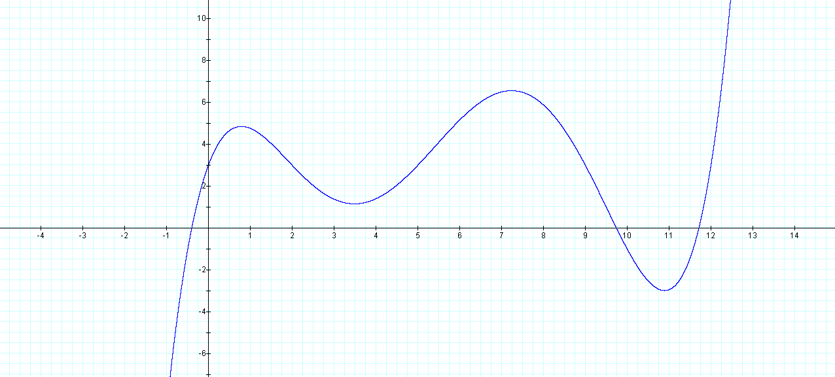

10) ______

(A) y = f’(x) (B) y = f’(x)

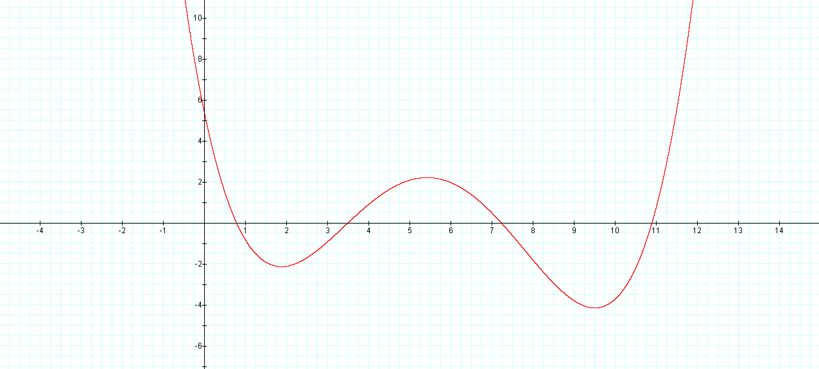 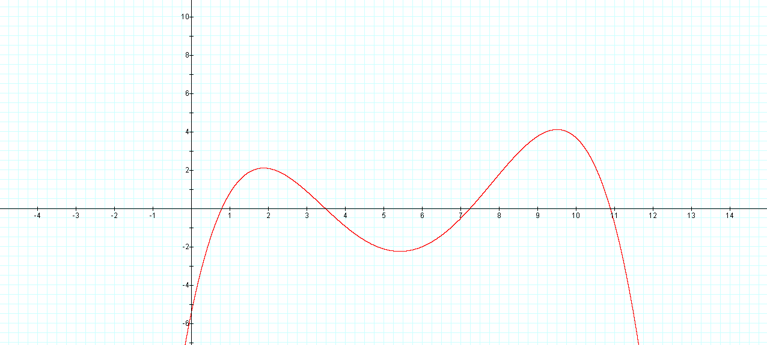

(C) y = f’(x)

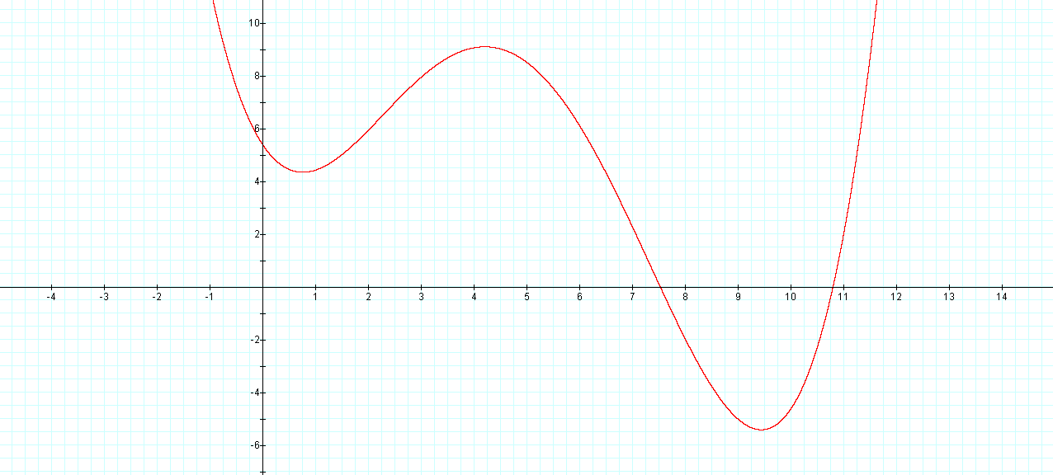

(D) y=f’(x)

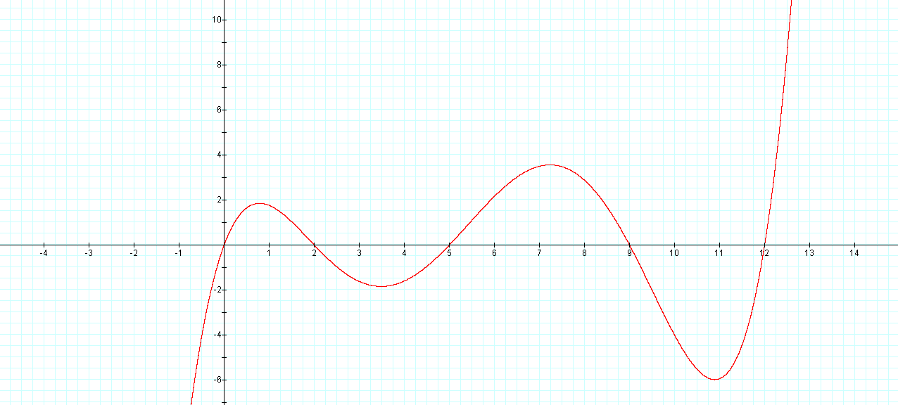

(E) none of the above

**11.** Find the derivative of the function g(x) = 

11) ______

(A) 

(B) 

(C) 

(D) 

(E) none of the above

**12. True or False** (If your answer is true, explain your reasoning; if your answer is false give a counterexample).

If f is continuous on [a, b], then

 = f(x)

12) ______

**13.** Find an equation of the tangent line to the circle x2 + y2 = 4 at the point (, -1).

13) ______

(A) y = x – 4

(B) y = x – 1

(C) y = x – 4

(D) y = x – 1

(E) none of the above

**14.** The graphs of f, f’, and f’’ are shown. Identify which of the three graphs (A, B, C) is f, f’, and f’’. Explain your reasoning.

B

C

A

14) ______

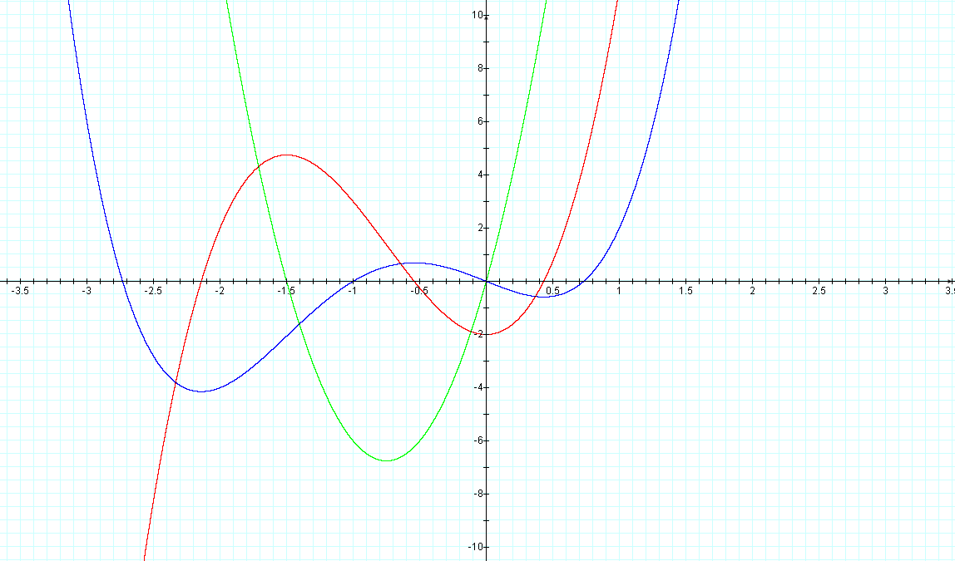

**A = _______ B = _______ C = _______**

**15.** Determine from the graph whether the function has absolute extreme values on the interval (a, b).

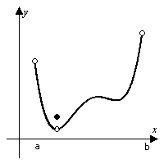

15) ______

(A) Absolute minimum and absolute maximum

(B) Absolute minimum only

(C) Absolute maximum only

(D) No absolute extrema

(E) none of the above

**16.** The acceleration, a = , initial velocity v =  and initial position of a particle moving along a coordinate line are given below. Find the particle's position at time t.

a = et; v(0) = 12, s(0) = 14

16) ______

(A) s = et + 11t + 13

(B) s = et + 11t

(C) s = et + 12t + 14

(D) s = et + 13

(E) none of the above

**17.** The graph of a function f is shown. Which graph is an antiderivative of f and why?

1. ______

B

A

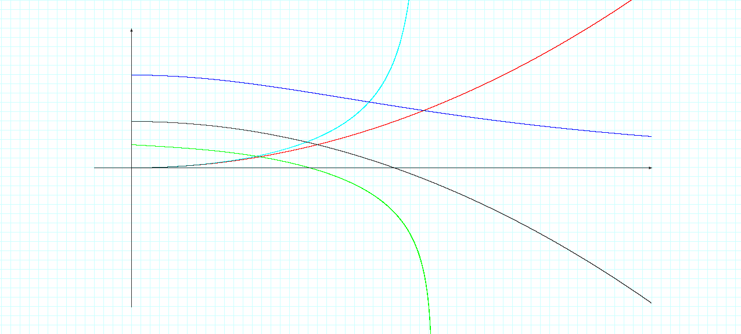

C

D

f

1. Graph A
2. Graph B
3. Graph C
4. Graph D
5. none of the above

**18.** Evaluate  18) ______

(A) 

(B) 

(C) 

(D) 

(E) none of the above

18) ______

**19.** Let y = . Find y’

19) ______

(A) 

(B) 

(C) 

(D) (4x + 9)3/2

(E) none of the above

**20.** Raindrops increase in size as they fall and so their resistance to falling increases. Suppose a raindrop has an initial downward velocity of 10 m/s and its downward acceleration is

a(t) = 

If the raindrop is initially 500 m above the ground, how long does it take to fall?

20) ______

(A) 9.8 s

(B) 10

(C) 11.8 s

(D) 13.6s

(E) none of the above

**21.** A water tank has the shape of an inverted circular cone with base radius 2 m and height 4 m. If water is being pumped into the tank at a rate of 2 m3/min, find the rate at which the water level is rising when the water is 3 m deep. (Hint: V = r2h)

21) ______

(A) 0.14 m/min

(B) 0.28 m/min

(C) 2.38 m/min

(D)16.75 m/min

(E) none of the above

**22.** Find the absolute maximum and absolute minimum values of f(x) = x – 2cos x on the closed interval [-,].

22) ______

(A) absolute min = -2.25; absolute max = -0.88

(B) absolute min = -2.62; absolute max = -0.52

(C) absolute min = -1.14; absolute max = 5.14

(D) absolute min = -2.25; absolute max = 5.14

(E) none of the above

**23.** Suppose f(0) = -3 and f’(x)  5 for all values of x. How large can f(2) possibly be?

23) ______

(A) 3

(B) 5

(C) 7

(D) 9

(E) none of the above

**24.** Determine the production level that will maximize the profit for a company with cost C and price function p:

C(x) = 84 + 1.26x – 0.01x2 + 0.00007x3 and p(x) = 3.5 – 0.01x

24) ______

(A) 48

(B) 103

(C) 224

(D) 350

(E) none of the above

**25.** Evaluate  25) ______

(A) 1/3

(B) -2/3

(C) 2

(D) 3

(E) none of the above

1. A rectangular corral is to be constructed with an internal divider parallel to two opposite sides,

and 1200 meters of fencing will be used to make the corral (including the divider). What is the maximum possible area that such a corral can have?

26) ______

1. The cost to manufacture $x$ computers per day is modeled by the following equation

27) ______

The *average cost $\overline{C}\left(x\right)=C\left(x\right)/x$* is defined to be the total cost divided by the quantity produced. How fast is $\overline{C}$ changing if the current production rate is 2000 computers per day and is increasing at the rate of 200 units per day?

1. *Increasing* by $1.01 per day
2. *Decreasing* by $1.01 per day
3. *Increasing* by $125.01 per day
4. *Decreasing* by $125.01 per day
5. None of the above
6. Find the linearization of at .

28) ______

2. None of the above
3. Engineers use innovative designs to improve the ability of buildings to withstand earthquakes. For example, the San Francisco International Airport uses giant steel ball bearings built into each of the 267 columns (see Figure below) which support the weight of the airport. Each ball bearing measures 5 feet in diameter with a maximum error of 0.01 feet. What is the maximum error for this diameter in computing the volume of this ball bearing?

29) ______

Building Support Column

Base

Ball Bearing

1. 0.785 ft3 (B) 0.685 ft3 (C) 0.575 ft3 (D) 0.365 ft3 (E) None of the above

**30.** Find the intervals on which the function f(x) = x2/3 (10 - x) is increasing and decreasing. Sketch the graph of y = f(x) and identify any local maxima and minima. Any global extrema should also be identified.

30) ______

(A)f(x) is decreasing on the interval (-, 0) (4, ); increasing on (0, 4)

(B) f(x) is increasing on the interval (-, 0) (4, ); decreasing on (0, 4)

(C) f(x) is decreasing on the interval (-, 10) (10, )

(D) f(x) is increasing on the interval (-, 0) (0, )

(E) none of the above

**31.** Sand falling from a hopper at 10 ft3/s forms a conical sand pile whose radius is always equal to its height. How fast is the radius increasing when the radius is 5 ft?

31) ______

(A) 5 ft/sec

(B) 10 ft/sec

(C) 2/5 ft/sec

(D) not enough information

(E) none of the above

**32.** Show that the function f(x) = x3 + x - 4 satisfies the hypotheses of the mean value theorem on the interval [-2, 3]. Find all numbers c in that interval which satisfy the conclusion of that theorem.

32) ______

(A) f is continuous on [-2, 3]; f ’ is continuous on (-2, 3); c = 

(B) f is continuous on [-2, 3]; f ’ is continuous on [-2, 3]; c = -

(C) f is continuous on [-2, 3]; f ’ is continuous on (-2, 3); c =  & -

(D) f does not satisfy the Mean Value Theorem

(E) none of the above

**33.** Sketch the graph of the function, indicating all critical points and inflection points. Apply the second derivative test at each critical point. Show the correct concave structure and indicate the behavior of f(x) as x 🡪 , for f(x) = 4x5 – 5x4

33) ______

**34.** Sketch, by hand, the graph of f(x). Identify all extrema, inflection points, intercepts, and asymptotes. Show the concave structure clearly and note any discontinuities.

f(x) = 

**35.** An aquarium has a square base made of slate costing 8¢/in2 and four glass sides costing

3 ¢/in2. The volume of the aquarium is to be 36,000 in3. Find the dimensions of the least expensive such aquarium.

35) ______

(A) l = 30 inches; w = 30 inches; h = 40 inches

(B) l = 20 inches; w = 20 inches; h = 90 inches

(C) l = 30 inches; w = 40 inches; h = 30 inches

(D) not enough information

(E) none of the above

**36.** Two aircraft approach Foley Field at the same constant altitude. The first aircraft is moving south at 250 km/h while the second is moving west at 600 km/h. At what rate is the distance between then changing when the first aircraft is 60 km from the field and the second is 25 km from the field?

36) ______

(A) 6000 km/hr

(B) 6000/13 km/hr

(C) 30,000 km/hr

(D) not enough information

(E) none of the above

**37.** Find the open intervals on the x-axis on which the function f(x) = x4 + 4x3 is increasing and those on which it is decreasing.

37) ______

(A) f is increasing on (-, -3); f is decreasing (-3, ).

(B) f is decreasing on (-, -3); f is increasing on (-3, ).

(C) f is increasing on (-,)

(D) f is increasing on (-, -4) (0, ); f is decreasing on (-4, 0)

(E) none of the above

**38.** Show that the function f(x) =  satisfies the hypotheses of the mean value theorem on the interval [0, 4]. Find all numbers c in the interval that satisfy the conclusion of that theorem.

38) ______

(A) f is continuous on [0, 4]; f ’ is continuous on (0, 4); c = 1/2

(B) f is continuous on [0, 4]; f ’ is continuous on [0, 4]; c = 1

(C) f is continuous on [0, 4]; f ’ is continuous on (0, 4); c = 1

(D) f does not satisfy the Mean Value Theorem

(E) none of the above

**39.** Evaluate:  39) ______

(A) 3 (B) 2 (C) 1 (D) 0 (E) none of the above

**40.** Evaluate:  40) ______

(A) 14 (B) 16 (C) 50/3 (D) not possible (E) none of the above

**41.** Evaluate:  41) ______

(A) 5.5 7 (B) 6.93 (C) 7.82 (D) 8.43 (E) none of the above

**42.** A stone is dropped from the top of a building 960 ft high. What will its impact velocity be?

42) ______

(A) 64 (B) -64 (C) 64 (D) -64 (E) none of the above

**43.** Evaluate:  43) ______

(A) 0 (B) 1/2 (C) 1 (D) -1 (E) none of the above

**44.** Evaluate:  44) ______

(A) 0 (B) 1/2 (C) 1 (D) -1 (E) none of the above

**45.** Which of the following functions has neither a local or global extreme value? Explain.

45) ______

1. f(x) = (B) f(x) = x2 (C) f(x) = x3 (D) f(x) = x4 (E) none of the above

**46.** Find the critical numbers of f(x) = |x|. Explain. 46) ______

1. 0 (B) -1, 1 (C) 1 only (D) There are no critical numbers (E) None of the above

**47.** Let M = f(t) and N = g(t) be the number of harmful bacteria A and B, respectively, at time t (measured in days). The graphs of f and g are shown in Figure A and B. Which model is a more harmful? Use concavity to explain your reasoning.

47) ______

Figure A: Bacteria A

M

t

10

100

t (days)

M = f(t)

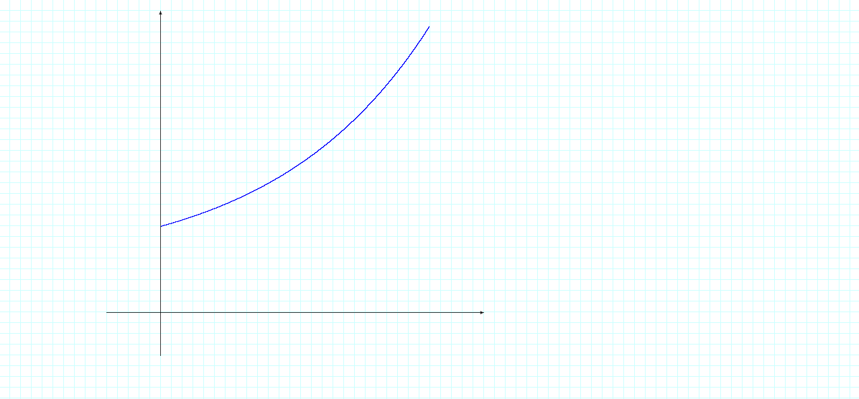

Figure B: Bacteria B

N

t

10

100

t (days)

N = g(t)

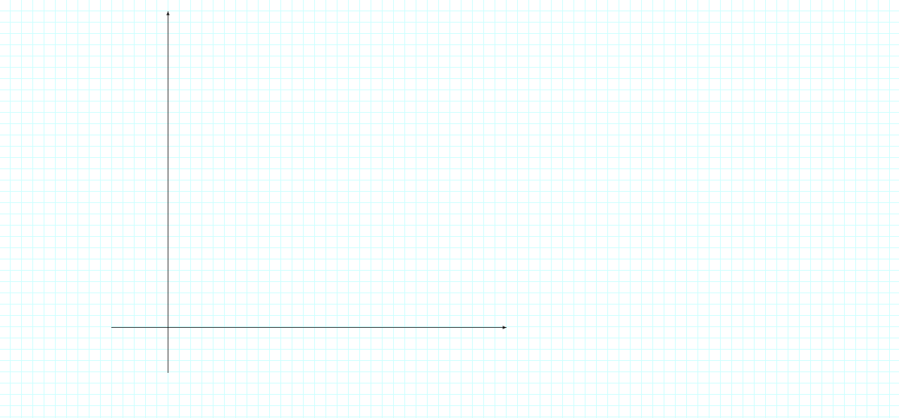

1. Bacteria A is more harmful (B) Bacteria B is more harmful

(Note: You must explain your reasoning in terms of concavity in order to receive credit.)

**48.** The graph in Figure below models the spread of the Ebola Virus during an outbreak in Zaire. Discuss the disease’s rate of increase changes over time. At what time is the rate of increase the highest? Explain.

48) ______

Figure: Number of Deaths Caused by Ebola Virus during Zaire Outbreak

t (measured in weeks)

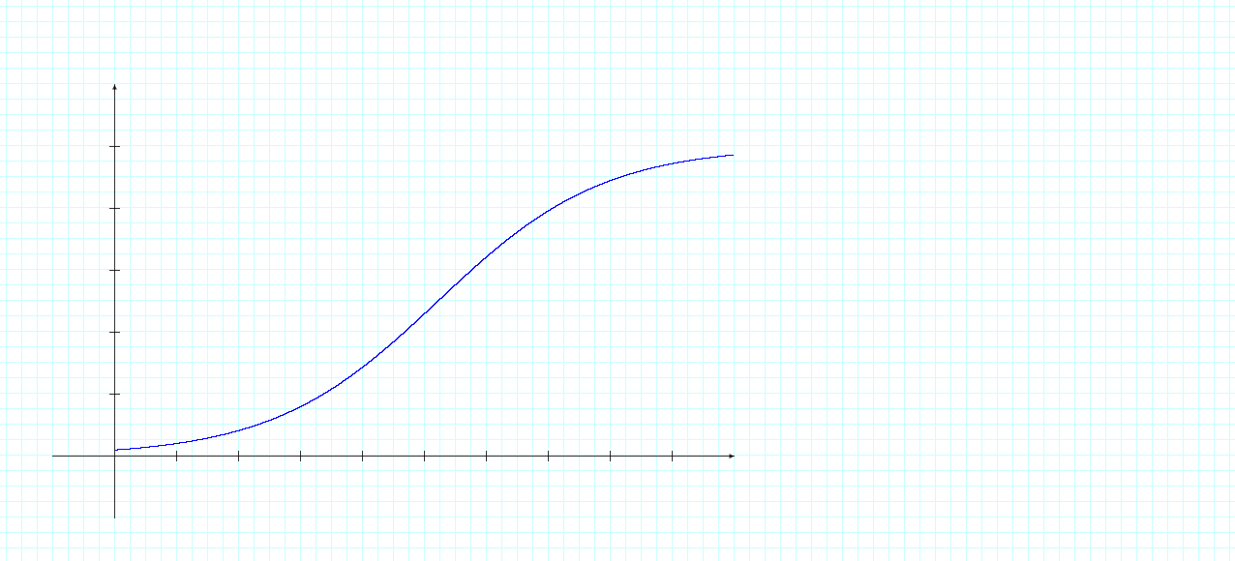

120

180

300

240

60

y = D(t)

10

8

7

6

5

4

3

2

1

D

(Number of Deaths)

*Source:* Center for Disease Control and Prevention

1. t = 1 week (B) t = 4 weeks (C) t = 5 weeks (D) t = 10 weeks (E) none of the above

**49.** Use the following conditions to sketch a graph of the function f(x).

(1) f(0) = 0, f(-1) = f(1) = 3, f(-2) = f(2) = 5, f’(-2) = f’(0) = f’(2) = 0

(2) f’(x) > 0 on (-, -2)  (0, 2), f’(x) < 0 on (-2, 0)  (2, )

(3) f’’(x) > 0 on (-1, 1), f’’(x) < 0 on (-, -1)  (1, )

49) ______

**50.** The cost and price functions for a new Internet search company are reasonably approximated by the following models:

50) ______

C(x) = 37 + 1.42x – 0.0067x2 + 0.00011x3 p(x) = 3.7 – 0.007x,

Where x represents the number of searches (in millions) per month. Find the ideal number of searches this company can manage (to maximize profit) per month.

1. Approximately 65 million searches per month
2. Approximately 76 million searches per month
3. Approximately 82 million searches per month
4. Approximately 97 million searches per month
5. None of the above